Statistics for engineers. Exercise sheet 2: Normal distribution

1. A variable y is normally distributed with mean 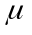=25 and standard deviation =1.5. Calculate the standard normal variable corresponding to the following values of the variable:
(i) 26.5 ; (ii) 28 ; (iii) 22 ; (iv) 23.5 .

2. For the variable defined in question 1 above calculate the probabilities that an observation taken at random from that population will be:
a) equal to or less than each of the four the values specified ;
b) will be greater than each of the four values specified .

3. A variable is normally distributed with mean =100 and standard deviation =3. Calculate the probability that an observation selected at random will be:
a) equal to or less than the following values:
(i) 103 ; (ii) 106 ; (iii) 97 ; (iv) 94 .
Explain why you answers are the same as those for part (a) of question 2 above.
b) between the values
(i) 97 and 103 ; (ii) 94 and 106 ; (iii) 97 and 106 .

4. A car manufacturer produces a model which has a fuel consumption figure which is normally distributed with a population mean of 45 m.p.g. and a population standard deviation of 2.5 m.p.g.
a) What is the probability that a customer purchasing such a car will obtain a fuel consumption figure of
(i) More than 50 m.p.g. ; (ii) less than 40 m.p.g. ; (iii) between 40 and 50 m.p.g. ; (iv) more than 43 m.p.g. and less than 48 m.p.g.
b) Determine the fuel consumption figure
(i) which will be exceeded by the top 2.5% of cars ; (ii) which will be exceeded by 97.5% of cars
(iii) which will be achieved by the middle 95% of cars. (iii) which will be achieved by the middle 90% of cars.

5. The time taken for a train to complete a specific journey is normally distributed with population mean 90 minutes and population standard deviation 10 minutes. A suggestion has been made that any customers using the train and arriving at the journey's end more than 15 minutes late should have their train fare refunded. If this suggestion were to be implemented what proportion of the journeys would be expected to incur a refund of fares?
A typical journey attracts a weekly fare income of £25,000 and there are 50 journeys per week. If the suggested policy on fare refunds is implemented how much money (in total) would you expect to be returned to customers in any given week?

6. A machine produces components with lengths which are normally distributed with mean μ and standard deviation σ. After each major service of the machine the machine is set to produce components to the customer specification of length μ=8.7 cm with an upper tolerance limit of 8.9 cm where the probability of exceeding the tolerance is 0.05.
i) Given the above information calculate the value of σ for this machine.
ii) The lower tolerance limit is not so important and so it is to be set at a value which rejects only 1 in 100 components. At what value should it be set?

7. i) A system of components is connected in the manner shown in the diagram overleaf:
The lifetime (time to failure) of each component is normally distributed. Using the suffices A, B and C to denote the components the mean and standard deviation of each component is:
μ_{A} = 44.0 ; σ_{A} = 2.0
μ_{B} = 42.0 ; σ_{B} = 2.6
μ_{C} = 40.0 ; σ_{C} = 3.7
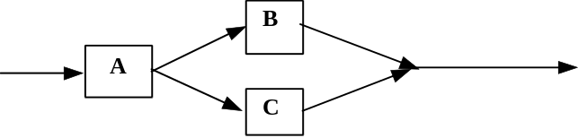
Find the probability that the system is still working after 45 hours.
You may assume that the failure of one of the units has no effect on the functioning of other units.

ii) The components in the system shown in part (i) above are rearranged so that they are connected in parallel. Find the probability that the new system fails before 45 hours.

Note: The solutions to this exercise can be found on the training section of the computer network. The file is a WORD6 document called ENG_SOL2.DOC and can be printed out in the usual way.

Normal Distribution Exercise Solutions

1. The variable y is normally distributed with mean =25 , standard deviation =1.5 .
(i) The value y=26.5 is 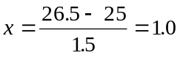 standard deviations above the population mean.

(ii) The value y=28 is 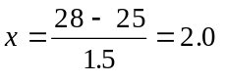 standard deviations above the population mean.

(iii) The value y=22 is 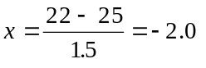 standard deviations below the population mean.

(iv) The value y=23.5 is 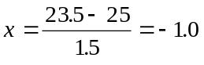 standard deviations below the population mean.

2. Call the variable y.
a) (i) We want P[y<26.5] = P[x<1] = 0.8413
The probability of obtaining an observation less than 26.5 is 0.8413.
(ii) We want P[y<28] = P[x<2] = 0.9772
The probability of obtaining an observation less than 28 is 0.9772.
(iii) We want P[y<22] = P[x<-2] = 1 - P[x>-2] = 1 - 0.9772 = 0.0228
The probability of obtaining an observation less than 22 is 0.0228.
(iv) We want P[y<23.5] = P[x<-1] = 1 - P[x>-1] = 1 - 0.8413 = 0.1587
The probability of obtaining an observation less than 23.5 is 0.1587.

b) (i) We want P[y>26.5] = P[x>1] = 1 - 0.8 415 = 0.1587
The probability of obtaining an observation greater than 26.5 is 0.1587.
(ii) We want P[y>28] = P[x>2] = 0.0228
The probability of obtaining an observation greater than 28 is 0.0228.
(iii) We want P[y>22] = P[x>-2] = 0.9772
The probability of obtaining an observation greater than 22 is 0.9772.
(iv) We want P[y>23.5] = P[x>-1] = P[x>-1] = 0.8413
The probability of obtaining an observation less than 23.5 is 0.1587.

3. Call the variable y. y is normally distributed with mean =100 and standard deviation = 3
a) (i) We want 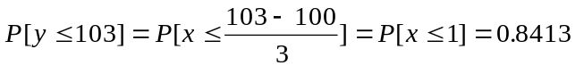
Note: This is the same probability as Question 2a)(i).
(ii) We want 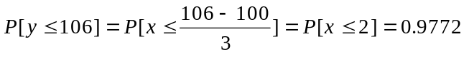
Note: This is the same probability as Question 2a)(ii).
(iii) We want 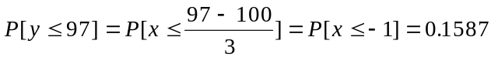
Note: This is the same probability as Question 2a)(iv).
(iv) We want 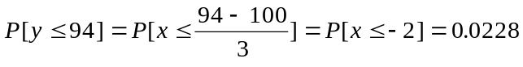
Note: This is the same probability as Question 2a)(iii).

3.(b)(i) We want
Or:
The probability of obtaining a y value between 97 and 103 is 0.6826.
(ii) We want
Or:
The probability of obtaining a y value between 94 and 106 is 0.9544.
(iii) We want
Or:
The probability of obtaining a y value between 97 and 106 is 0.8185.
Note: in this case the area in the lower tail is larger than that in the upper tail.

4. Call the fuel consumption y. y is normally distributed with population mean = 45m.p.g. and population standard deviation =2.5 m.p.g.
a) (i) We want 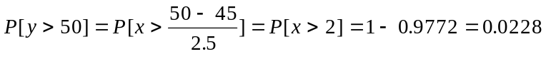
The probability of a customer purchasing a car with a fuel consumption better than 50 m.p.g. is 0.0228.
(ii) By symmetry (because 40 is 2 standard deviations below the mean) the probability of a customer purchasing a car with a fuel consumption worse than 40 m.p.g. is 0.0228.
(iii) The probability that a customer purchases a car which has a fuel consumption between 43 m.p.g. and 48m.p.g. is
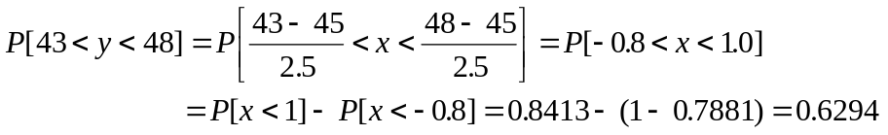
There is a probability of 0.6294 that a car will have a fuel consumption somewhere between 43 and 48 m.p.g.

b) (i) Call the value which is exceeded by 2.5% of the cars y₁ with a corresponding standard normal variable x₁
We want to choose y₁ so that P[y>y₁]=0.025 . This means that P[y<y₁] = P[x<x₁] = 0.975 .
From normal distribution tables (page 34) the value of x corresponding to and area of 0.975 is x₁=1.96
Hence 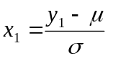 and in this case 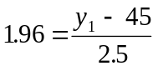
Rearranging this gives
In other words, 2.5% of cars will have a fuel consumption better than 49.9 m.p.g.
(ii) Call the required value of y y₂ with the corresponding standard normal variable x₂ . By symmetry, if 2.5% of the values are less than y₂ then this value must be 1.96 standard deviations below the mean. That is,
Or, 2.5% of cars are expected to have a fuel consumption worse than 40.1m.p.g.
(iii) The middle 95% of cars will have a fuel consumption somewhere in the range
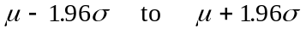
Using our values of and gives this range as
that is, between 40.1 m.p.g. and 49.9 m.p.g.
(iv) To find the range of the middle 90% of fuel consummations first find the value of x corresponding to 5% in the upper tail and 95% in the lower tail. From the tables this value is x=1.645. This gives
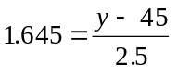
which can be rearranged to give y = 45 + 4.1125 = 49.1125 m.p.g.
By symmetry a fuel consumption of 45 - 4.1125 will have 5% of the population below it. Hence 90% of cars will have a fuel consumption in the range 40.8825 to 49.1125 or 40.9m.p.g. to 49.1 m.p.g. to 1d.p.

5. Call the time taken for the journey t. t is normally distributed with a population mean =90 min. and a population standard deviation =10 min.

Assuming that the published journey time is the population mean, any journey taking longer than 90+15=105min. will require a refund.
First find the standard normal variable corresponding to 105 mins. This is 1.5 (105 is 1.5 standard deviations above the mean). Hence
Hence 0.0668 or 6.68% of journeys will require a refund.
With 50 journeys per week bringing in £25k per journey the total income is £1250k per week. Of this 6.68% is expected to be returned to the passengers, i.e. 120x0.0668=£83.5k in any given week.

6. Call the length of the component y, where y is normally distributed with mean μ and standard deviation σ.
The mean is set at μ = 8.7 cm. The upper tolerance is at 8.9 cm.

(i) We are told that P[y > 8.9] = 0.01 hence P[y ≤ 8.9] = 0.99 .
The standard normal variable corresponding to y is x = (y - μ)/σ .
For y = 8.9 x = (8.9 - 8.7)/σ or σ = (8.9 - 8.7)/x
We do not know σ but we can find x from normal distribution tables:
P[x ≤ 1.64] = 0.9495
P[x ≤ 1.65] = 0.9505
Using linear interpolation P[x ≤ 1.645] = 0.9500
Hence, σ = 0.2/1.645 = 0.1216 cm.
If the information supplied is correct then the standard deviation of the length variable is 0.1216 cm.

(ii) We now know that μ = 8.7 cm. and σ = 0.1216 cm.
We are told that the lower tolerance limit is the value of y below which 0.01 of the lengths lie. Call this value y_{L}, which is less than μ = 8.7.
P[y ≤ y_{L}] = 0.01 . Let the standard normal variable corresponding to y_{L} be x_{L}, then P[x ≤ x_{L}] = 0.01
P[x > x_{L}] = 0.99 .
From tables P[x ≤ 2.33] = 0.9901
By symmetry we have P[x > -2.33] = 0.9901 and P[x ≤ -2.33] = 0.0099 .
Hence
If there are to be 1 in 100 components below the lower tolerance limit that limit should be set at 8.4167 cm. If all data is given to 2 decimal places then the tolerance should be rounded to 2 places, bearing in mind that this will slightly alter the related probability.

7. (i) Use the subscripts A, B and C to refer to components A, B and C respectively.
Call the probability that component A still functions after 45 hours event A.
Call the probability that component B still functions after 45 hours event B.
Call the probability that component C still functions after 45 hours event C.
The first step is to determine how the event inter-relate.
In order for the system to function A must work AND B OR C OR B∩C ,
that is event A∩(B ∪ C) = (A∩B) ∪ (A∩C) .
You can work with either form using the relationship P[E ∪ F] = P[E] + P[F] - P[E ∩ F]
where E = A ∩ B and F = A ∩ C .
P[(A∩B) ∪ (A∩C)] = P[A∩B] + P[A∩C] - P[(A∩B) ∪ (A∩C)]
= P[A∩B] + P[A∩C] - P[(A∩B∩C)]
= P[A]×P[B] + P[A]×P[C] - P[A]×P[B]×P[C]
assuming independence of events A, B and C.
We now need to determine P[A], P[B] and P[C]. Call the times to failure of the components t_{A}, t_{B} and t_{C} .

Substituting P[A] = 0.3085 , P[B] = 0.1251 and P[C] = 0.0885 into the equation for P[(A∩B)∪(A∩C)] gives 0.0625 as the probability that the system will still be functioning after 45 hours.

(ii) If the components are linked in parallel the probability that the system fails before 45 hours is given by the probability that all three components fail, that is
P[system fails before 45 hours] = P[(A fails)∩(B fails)∩(C fails)]
= P[t_{A} ≤ 45]×P[t_{B} ≤ 45]×P[t_{C} ≤ 45]
= 0.6915×0.8749×0.9115 = 0.5515 .
For a system where the three components are set up in parallel there is a probability of 0.5515 that the system will fail before 45 hours.

N.B. There is often more than one way of arriving at the answer to a problem. So long as you have used the correct reasoning every approach is equally valid.

